**Design Document**

Dirty Water

______

University of Washington Tacoma

Jeffrey Weiss

TCSS 360

______

https://dirtywater.github.io

dirtywater365@gmail.com

https://discord.gg/GM3xgYg

______

**TEAM:**

Michelle Brown

Jim Phan

David Guerrero

Caleb Wheeler

**Table of Contents**

**Title pg.**

Table of Contents 2

Rationale 3

Class Diagram 5

Startup Sequence 6

User Story Sequence Diagrams 7

US1 7

US2 8

US3 9

Extra 10

**Rationale Summary**

Our design for this project follows the MVC pattern. It’s the easiest form to follow and allows us to separate the classes into different sections based on what we need them to perform. The project’s main focus is to have data be stored in the Project class which is managed by the ProjectManager. This is used to allow us a gathered location of data the user inputs and customizes as the user will need to store that data into a text file in between sessions. The Project Manager exists as to allow the user to control multiple projects at one time.

When applying our design to the Object-Oriented Programming Heuristics, we can examine if our design follows these heuristics. Examining if the project follows uniformed work, we can say most of the system does so. The class that may perform more work would be the Project class as it is used by other classes due to its nature as being the class that stores the user’s data at run time. Examining the second heustritic design, we separated the classes as not to create god classes however we did design classes with ‘Manager’ in their names. This is a design choice as the Manager classes are necessary in order to allow for the changing of the panels the user can view and for the multiple data the user can access.

The majority of this design follows the ten heuristics given to us. While some can be suspect such as our naming conventions of the ‘Manager’ classes, the rest keep true to our MVC pattern. We have had to remove some classes as other classes would allow for a simplified version of this project. We haven’t come into issues with having to remove other classes but the design seems to hold on its own. Overall, the project’s design keeps true to the ten heuristics we hold if not a few suspect issues.

**Class Diagram**

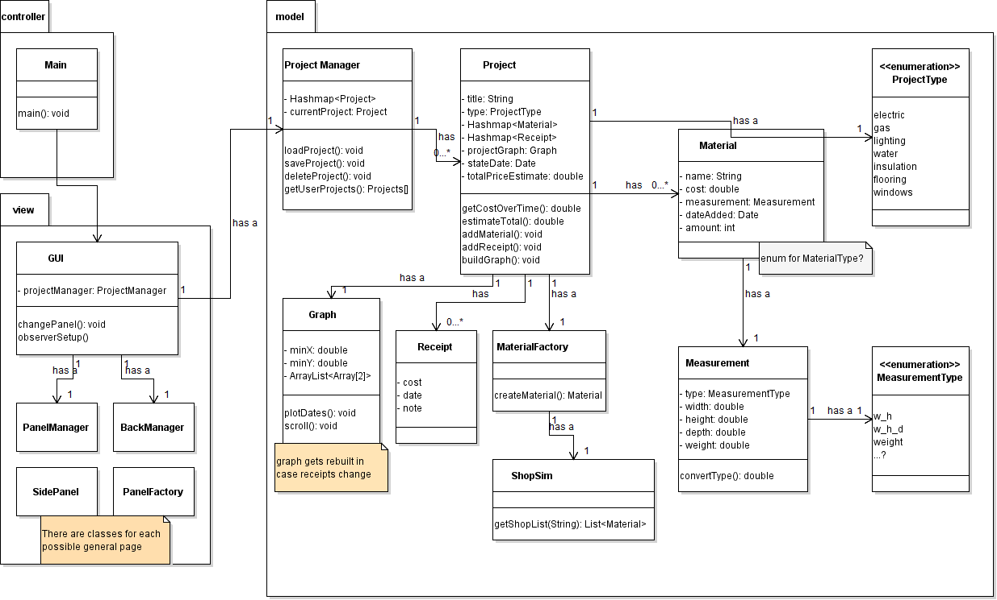

**Startup Sequence**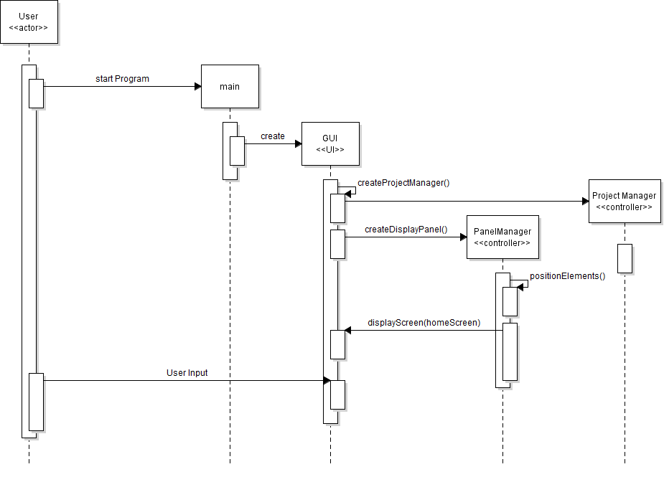

**User Story Sequence Diagrams**

**US01. As a DIYer, I want to store data and measurements for my DIY projects so I can refer to them any time.**

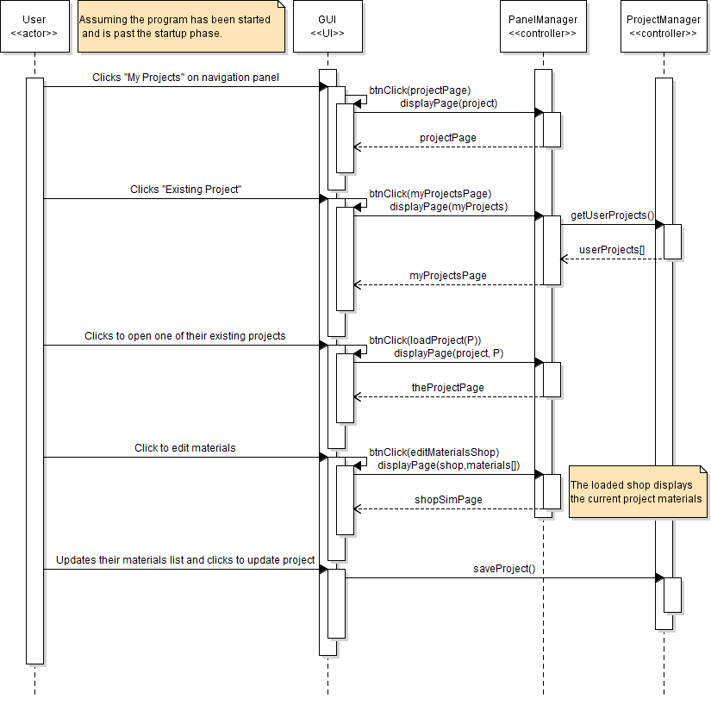

**US02. As a homeowner, I want to document my home's energy efficiency.**

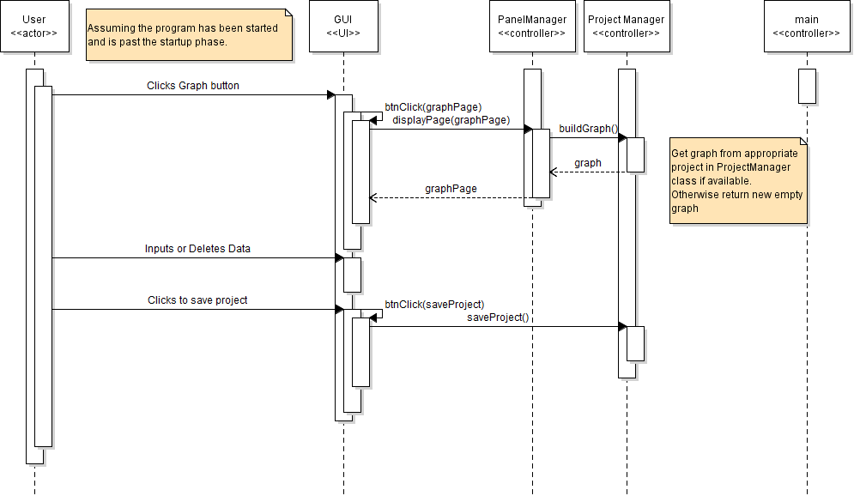

**US03. As a user, I want to make price calculations based on the data I assemble so I can estimate project costs.**

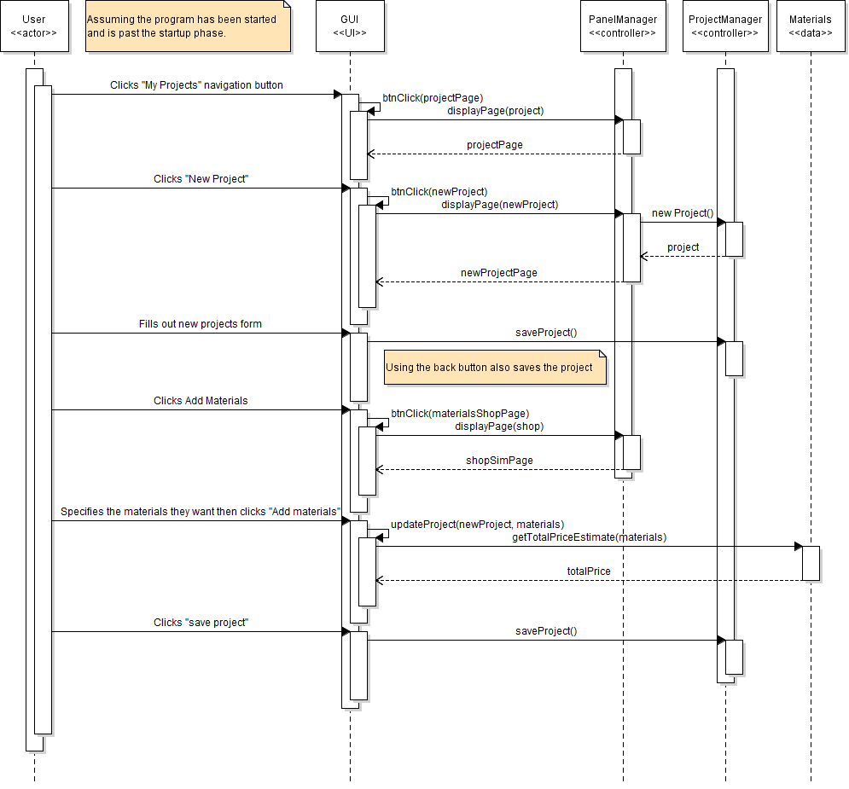

**Extra. As a user I want to export settings for synchronization to other devices.**

